Below are the implementation Steps used for UNXS0391.CMD.QM1 for Dead letter queue:

1. Create initiation queue. Queue Type local  **(say TRIGGER.INITIATION.LOCAL)**
2. Create a backup queue where you want to transfer file **( say DEAD.LETTER.BACKUP)**
3. Create scripts using qload and name the file as ******.sh. Provide execute access to the script .

**Script command: qload -m UNXS0391.CMD.QM1 -I UNXS0389.CDN.QM1.DEAD.LETTER.QUEUE -o output_queue**

**Location:/var/mqm/scripts/MFTScripts/**

1. create process definition as per screenshot below:

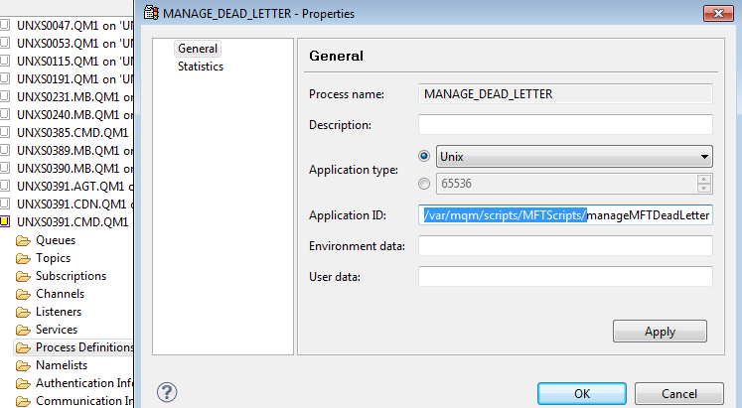

1. add trigger to dead letter queue as per screenshot below:

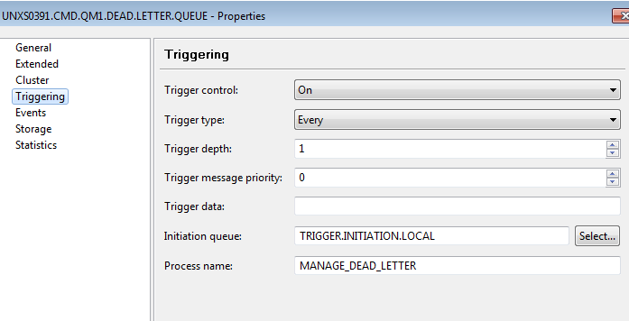

1. Run the runmqtrm command from the unix box.

nohup /usr/mqm/bin/runmqtrm -m UNXS0389.CDN.QM1 -q TRIGGER.INITIATION.LOCAL &

Check:

* + Check that runmqtrm is running fine or not: **ps -ef | grep runmqtrm**
  + Place a message in dead letter queue and observe if it moves to backup queue successfully or not.